AZHAR ALI

023-23-0314

**Sec A**

LAb 3

DSA 2024

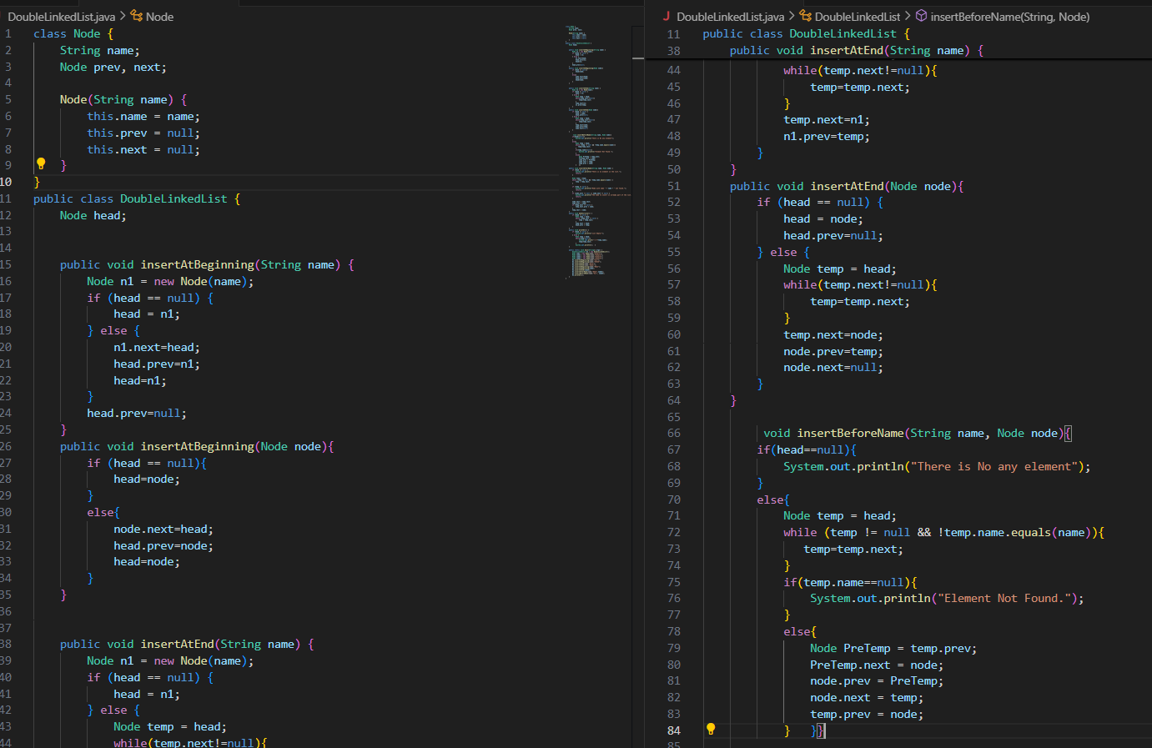**1. Understand provided code and implement all required methods (with all possible exceptions) in DoubleLinkedList.**

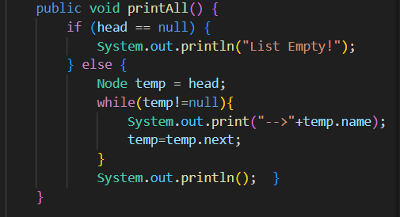

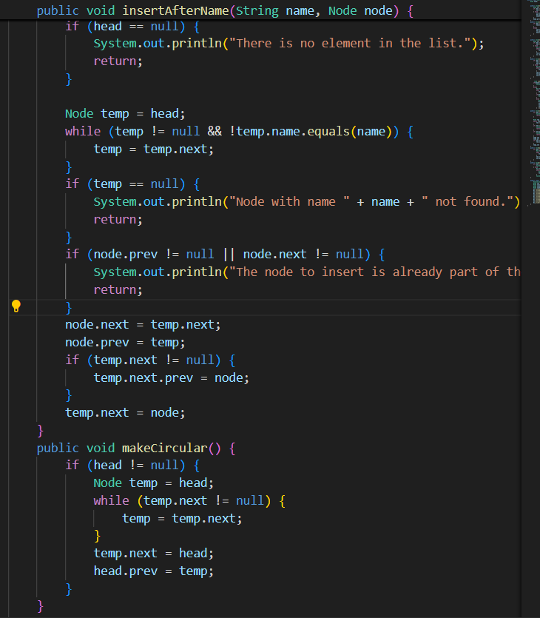

**Output**

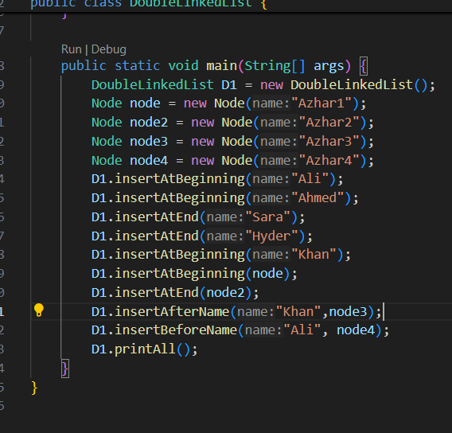

**Main**

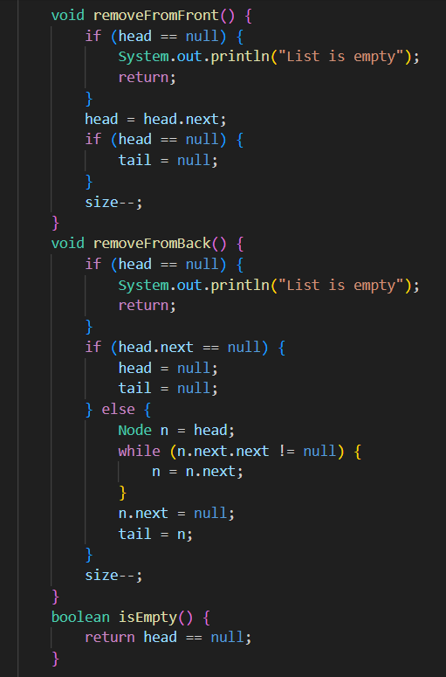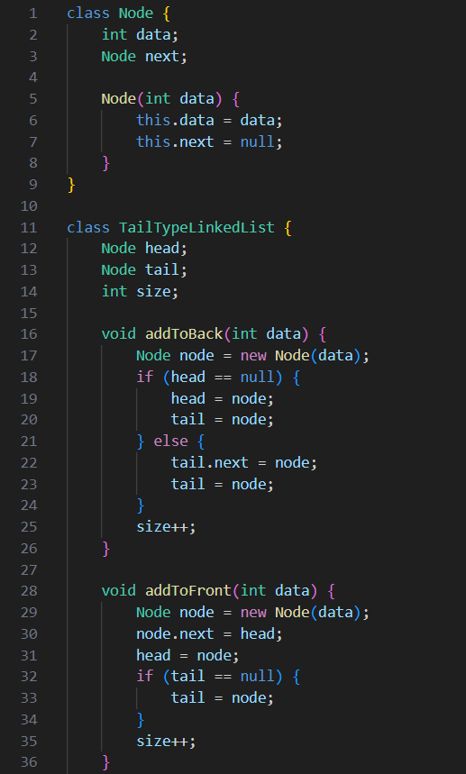**2. In previous labs, you have designed single linkedlist with all possible common methods with only head. Now your task is to implement following methods (Single/Double LL) but this time you have to make another variable say tail for accessing last element directly. - All types of methods for inserting (Beginning, End) - All types of methods for removing (Beginning, End) Compare these methods with those which were designed without tail.**

**Main Method**

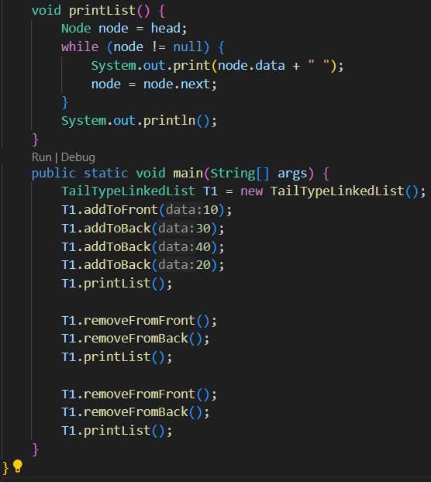

**Output**

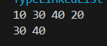

3**. Design a method that takes head as param and detect whether linked list contains cycle or not? Cycle exists in a linked list if any node is visited twice while traversing whole traversing**.

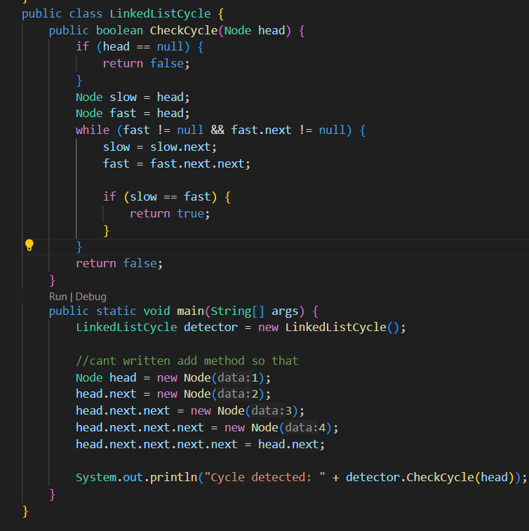

**Output**